MART 120

Homework 2

Nancy Rowley

**Learning Style:**

<http://www.educationplanner.org/students/self-assessments/learning-styles-quiz.shtml?event=results&A=6&V=7&T=7>

**Your Scores:**

* Auditory: 30%
* Visual: 35%
* Tactile: 35%

You are a **Visual/Tactile** learner! Check out the information below, or [view all of the learning styles](http://www.educationplanner.org/students/self-assessments/learning-styles-styles.shtml).

I found this quiz to be revealing about my well-rounded learning abilities.

I believe I use a Visual style of learning when I am in a new area and getting a “lay of the land” with physical landmarks for reference. Unfortunately, if they remove or trim the large bushy tree on the corner, I may get very lost or get someone else very confused with my directions.

I graduated with my AS in Pharmacy Technology May of 2010. I failed the first six-week module because I could not retain the generic and name brand drug names, as well as fractions for percent of change. A couple students that sat next to me in class started quizzing me on conversions and drug names. I did not have money for a recorder and could not take up too much time of my supportive fellow students. Therefore, I called myself and left voicemails for myself recording the drug name then waiting a few moments to say the alternate name. I called my voicemail allot before getting a recorder. Quickly my test scores increased.

Another way I found that I am a visual learning is with colored que cards and writing with colored ink. During a test I would imagine the color of the card or ink. Then I would try to imagine what letter it started with and had better results than just black ink and white que cards.

I feel this quiz summarized what I knew about my learning style and showed that I learn different things in different ways.

**Mind Set:**

My Mindset score was 58 suggesting a strong growth mindset. I have changed course many times in my life. This could have been due to the economy or a bad roommate but being able to be flexible is important for survival. Anything is possible if you put your mind to it and will to bend, not break.

I believe we are learning or stagnating. At most jobs I have ever worked I learned something new every day. I have received valuable constructive criticism that has helped shape me into the person I am today. I feel that although we have to push ourselves, we are only as good as our best competition. Therefore have a life coach or just someone in your life to help coach you is so valuable. I was very fortunate to grow up in a household where my brother and I were told me can do anything we put our minds to. My Mom was adventurous and encouraged us to try new things and “Break a Leg”. There is something to be learned from making mistakes that must be accepted and appreciated.

**Randy Pausch:**

I really appreciated the lecture by Randy Pausch. I identified with many parts of his message and his medical condition. My Mom passed away 3-15-2020 at 58 with pancreatic cancer, 5 weeks after diagnosis. That and at the end of the lecture when he explained that the reason for his lecture was to help show us “The way to lead your life and for my kids”. It was funny and still very relevant.

I agreed with every point he made but some where touching and thought provoking. When he spoke about some Brick walls of life are made of flesh, I laughed out loud because I have had this experience more times than I can count. It helps to understand others wants and needs when trying to compromise. Arguing never leads to the wanted outcomes. There are a time and place when you need to be like water and passively go around your brick walls.

Randy asked the question “How much do you want it?” I feel like we are on our path but when we have our eye on the destination, we are not looking at our path we are just on our way. It does not matter how you get there but that you keep working to get there. If we are open to any possibilities, we may meet people or have unexpected coincidental synchronicities that end up getting us to a destination better than anything we could have imagined to planned for.

He made me laugh when someone told him “You’re a good salesman, you might as well sell education.” After my Catering career in High School, I started my Administrative career that led to a great Sales and Marketing career. When I felt I needed more stability I attended Carrington College and graduated with my AS in Pharmacy Technology. After returning to my Carrington campus I was recruited and started working higher education and found that I loved it. I never lost my natural sales abilities. I grow produce that I, used to Pre-Pandemic, sell at the Farmers Market. There was some haggling required that was fun and fulfilled my need for a little sales excitement.

Virtual Reality is the most exciting thing in technology. I am not really a Gamer because I just don’t have the time. At one time I was strongly considering acquiring the Xbox because of the new VR headsets and gaming options. This an exciting time to be getting into the technology of computer coding. I’m looking forward to adding coding to my toolbox of professional skills.

I have been so lucky to have a great family support system. My amazing friends have always been there for me no matter what and have had more colleagues enrich me with their acquired knowledge and experience that has saved me from many of the pitfalls of life. Randy helped show the full picture of how you childhood goals can be achieved but it’s the journey not the destination that matters the most.

This lecture was inspiring. Although I know to keep following your dreams no matter what the circumstances of your life it was refreshing to have that real life firsthand confirmation. Life is short, no one makes it out alive, so we better make the best of it.

**Code.org:**

This was fun and helped to show the layering and connecting of codes. Illuminate was awe inspiring and shows there no end the possibilities with coding.

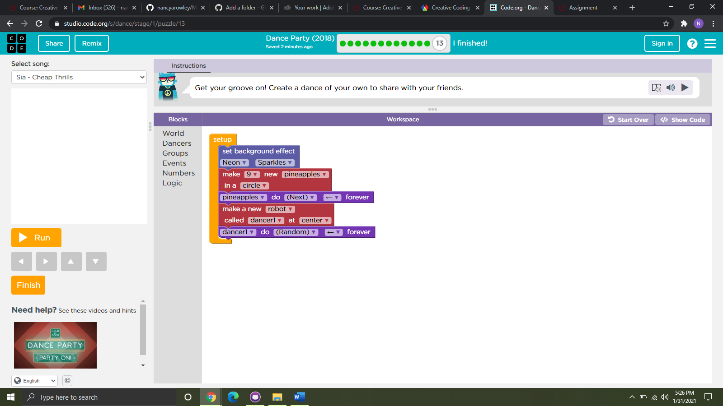

**Artist Lab:**

Below is a link to my project and attached screen shot.

My first piece of coding art! I could not get the stickers to turn the correct directions for my under-water scene. It was interesting to see the coding process with blocks.

<https://studio.code.org/c/1298709074>

